Summary of Data Sets and Rationale
Customer Demographics: Included to segment churn behaviour by Age, Gender, and Income
Transaction History: Included to track spending behaviour across categories such as Groceries and Electronics.
Customer Service: Included to measure the impact of resolution status on customer loyalty.
Online Activity: Included to evaluate digital engagement through login frequency
Churn Status: The target variable used to identify whether a customer has exited the service

The Exploratory Data Analysis (EDA) revealed several critical business trends:
- Core Metrics: The overall churn rate for the 1,000-customer sample is 20.4%.
- Age Segment Risk: Customers in the 36-45 age bracket exhibit the highest churn rate at 26%, making them a high-priority retention target.
- Service Failure Impact: A significant "Resolution Gap" exists where 50.1% of service interactions (335 out of 668) remain Unresolved, a primary
- Digital Engagement: Online Banking is the most preferred platform (26.86 avg. logins), while the Mobile App sees lower engagement (25.04 avg. logins).
- Economic Correlation: Low-income customers churn at a higher rate (22%) compared to High-income customers (19%).

Data Cleaning and Preprocessing Steps
The following technical steps were taken to ensure data quality and model readiness
- Data Integration: Established a Star Schema relationship in Power Pivot, using CustomerID as the primary key to link demographic data to behavioural and service data.
- Handling Inconsistencies: Resolved "(blank)" records caused by referential integrity issues between the Churn and Demographic tables
- Normalization/Encoding: Categorized raw AmountSpent and Age into manageable bins (e.g., 18-25, 26-35) for clearer statistical grouping.
- Relationship Validation: Corrected "Many-to-Many" relationship conflicts to ensure filtering between the Master Table and fact tables (Service and Churn) worked correctly.

INSIGHT

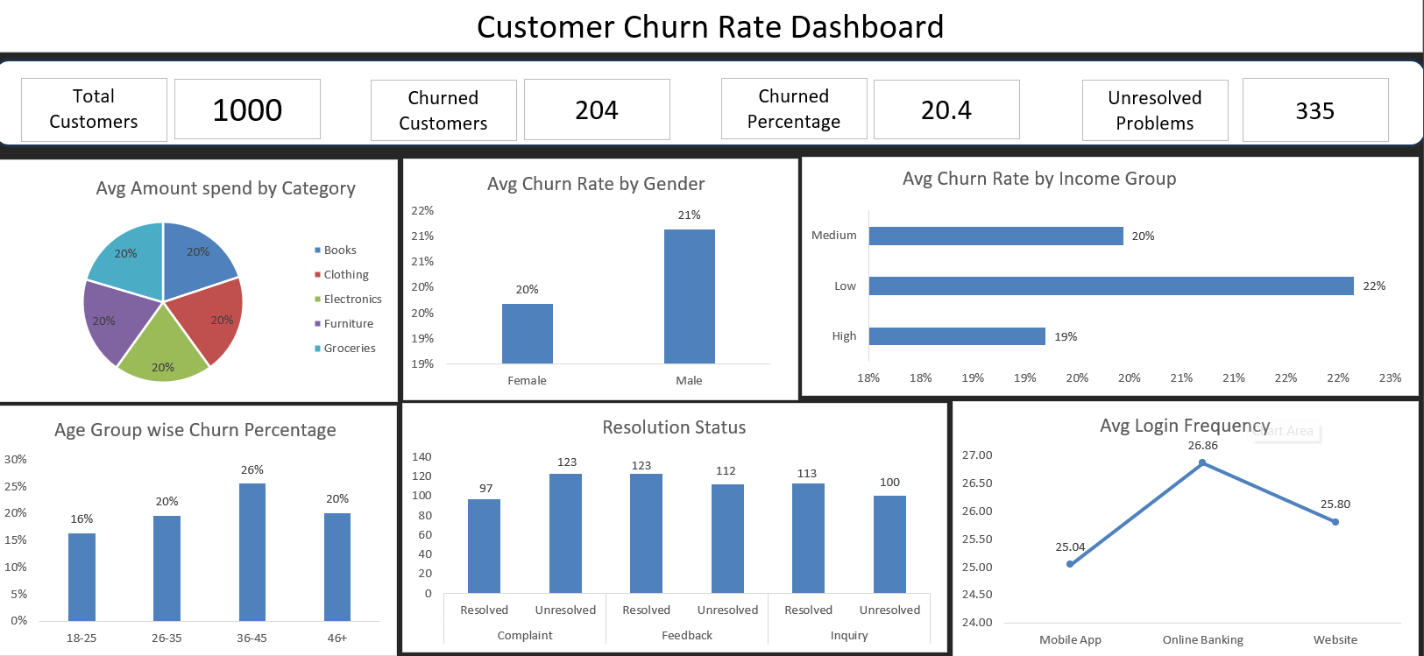

The overall churn rate was identified at 20.4%, indicating that approximately one in five customers are leaving, which is a significant concern for business sustainability. Segment-wise analysis revealed that customers in the 36–45 age group and those belonging to the low-income category exhibit higher churn rates compared to other segments, making them high-risk groups.
A critical observation from the analysis is the high number of unresolved customer issues, which strongly correlates with increased churn. This suggests that poor customer service or delayed issue resolution is a major driver of customer dissatisfaction and attrition.
Additionally, customer engagement analysis showed that users of online banking services demonstrate higher activity levels, indicating that digital engagement can play a role in improving customer retention. However, spending patterns across product categories remained relatively consistent, suggesting that churn is not directly influenced by purchase behaviour.

Business Recommendation
To reduce churn, the organization should prioritize improving complaint resolution processes and focus retention strategies on high-risk customer segments, particularly middle-aged and low-income customers. Enhancing digital engagement and customer experience can further support long-term retention.

